Tenant Management System

Prepared for: Trenz Pruca, Title

Prep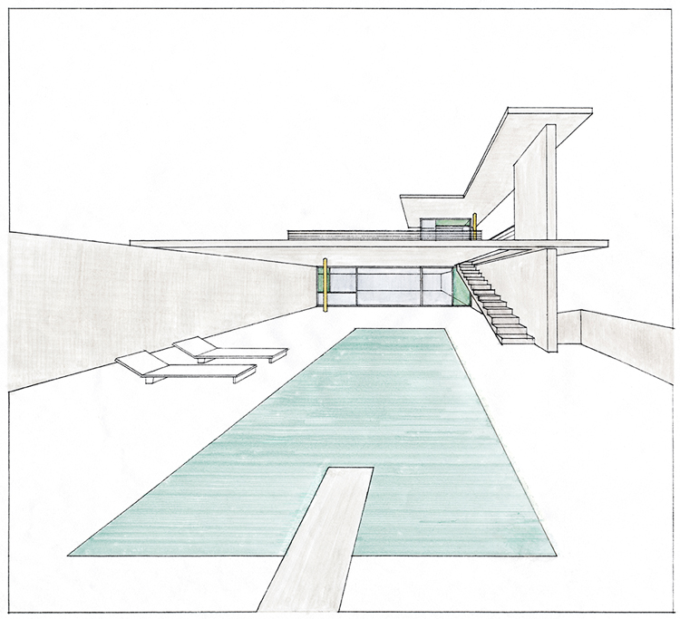ared by: Puneet Sharma , Senior Software Developer

LOYLTy rewardz

Dated : 2 October 2016

# Tenant MANAGEMEnt system

LOYLTY REWARDZ

## Author’s

| SR NO | NAME | EMAIL |
| --- | --- | --- |
| **1** | Puneet Sharma | [puneet.sharma@loytly.com](mailto:puneet.sharma@loytly.com) |
|  |  |  |

## Revision History

| SR NO | VERSION NUMBER | UPDATED ON | UPDATED BY | COMMENTS |
| --- | --- | --- | --- | --- |
| **1** | 1.0 | 01-10-2016 | Puneet Sharma | Initial Draft |
|  |  |  |  |  |

Table of Contents

Contents

1. Introduction
   1. Audience
   2. Acronyms
   3. Glossary
   4. Reference
2. Component Overview
   1. Component Functionality
   2. Component Architecture
   3. Component Design

loyalty rewardz

* 1. Assumptions & Open Issues

1. Other Design Aspect
   1. Infrastructure Consideration
   2. API’s
   3. Component Configuration
2. Traceability Matrix
3. Document Baseline

## 1. Introduction

The Purpose of this document is to outline the technical design of the **Tenant Management System** and provide an overview for the **Tenant Management System**

Its Main purpose is to -

* + - * Provide the link between the functional Specification and the detailed Technical Design documents.
      * Detail the functionality which will be provided by each component or group of components and show how the various components interact in the design.
      * Provide a basis for the **Tenant Management System** detailed design & development.

This document is not intended to address installation and configuration details of the actual implementation.

Installation and configuration details will be provided in technology guides produced during the course of project.

## 1.1 Audience

The intended audiences for this document are Project development team , technical architects & testing team.

## 1.2 Acronyms , Abbreviations, Terms & Definitions

Please refer to Appendix A for a list of all acronyms & abbreviations.

## 2 Component Overview